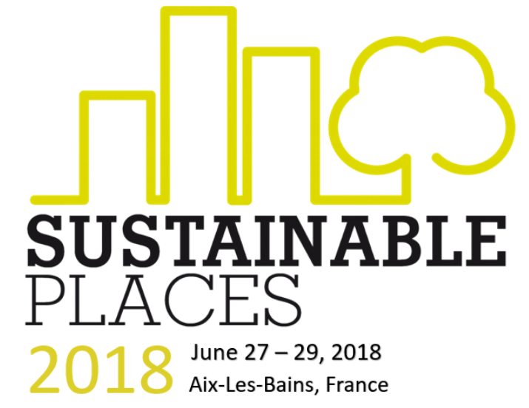
SUSTAINABLE PLACES SP2018
(SP2018)

CALL FOR PROPOSALS (CfP)
Through the present submission, the contributor confirms that:

- REGISTRATION
  - (S)he is available to assign a proxy or personally attend the SP2018 congress if the proposed contribution is accepted. Indicate person(s) traveling to [Aix-Les-Bains, FR], in the box marked “Attending author” in section 2-B.
  - The costs of her/his travel to and from, as well as the registration fee must be covered by her/his organization. Fees & discounts found in section 4-B.
  - At least one registration per accepted contribution is required per accepted abstract, except for workshops where at least three registrations (chairpeople) are required.

- PUBLICATIONS
  - The MDPI AG Proceedings applies to any authors who have been rejected by one of the 5 journal special issues, or for those authors who wish not to carry out any major revisions being requested by the journal’s editorial boards.
  - Blind peer review will occur only for extended paper types that become submissions to one of the 5 journal special issues.
  - Details in section 4 (specifically the submission timeline is in section 4-A, and the journal scopes are in section 4-C)

- GUIDELINES. Please send the completed CfP application form to the SP2018 conference chair via email at: zia.lennard@r2msolution.com no later than 1st April 2018.

SECTION 1 - Contribution(s) Type(s)

Instructions: Select the type(s) of contribution you want to submit (authors must submit separate CfP applications for each contribution type if multiple are desired. Up to three contribution type selections are acceptable for authors who have committed to registering for attendance at SP2018 on 27-29 June (e.g. poster + workshop + paper/briefing).

Conference or Journal Paper (+Presentation) |  | A 20-30 minute long presentation + full paper on mature research results that if accepted will start as a 4-page paper and become an extended 6-8 page scientific paper potentially published in one of the five special journal issues. At least one (co)author must attend the event to defend the paper. Please see section 4-A for timelines, section 4-B for discounts being offered, and section 4-C for journal scopes & paper submission details. (Co)authors shall receive direct communications leading up to and throughout the peer-review process. |  |  |  |  | 20-30’ PPT +  6-8 page full paper | ☐
Briefing (Presentation only, no paper) |  | A 20-30 minute long briefing on any (mature or immature) project, initiative, organization, or otherwise within the conference topics will be showcased during a thematic session at SP2018. The presentation shall be delivered by one of the authors or proxy collaborators, and at least one (co)author must attend the SP018 congress. Fees and discounts are detailed in section 4-B. |  |  |  |  | 20’ PPT | ☐
Clustering Workshop |  | A 90 or 180 minute (or otherwise proposed time-length) session designed to engage speakers and attendees in a productive interaction and to produce specific outcomes or demonstrate interactive results. Methodology, names of (AT LEAST) 3 REQUIRED registrants, and expected outcomes should be highlighted in section 2-B. If you need support to invite “sister projects” don’t hesitate to reach out via email to the conference chair at: Zia.Lennard@R2Msolution.com |  |  |  |  | Typically 90’ or 180’ | ☐
Posters & Media |  | Scientific & technical poster contributions (or mixed media installations) will be displayed in the exhibition hall (with full visibility to all attendees). The poster may potentially be defended in a dedicated track session, and at least one (co)author must attend the SP2018 congress. |  |  |  |  | Full visibility | ☐
SECTION 2 - Contribution(s) Type(s)

Instructions:

- Contribution theme (Section 2-A) Select applicable themes (area & focus) that fit with the scope of your contribution. This is to aid the program development of clustered tracks by topic.
- Contribution details (Section 2-B) Fill in the title, abstract, innovation, and name(s) of presenter(s) or workshop chairs expected to register for SP2018 to defend the contribution on-site.

Section 2-A) Topic
Area |  | Sustainable Buildings |  |  |  |  |  | ☐
 |  | Sustainable Districts & Cities |  |  |  |  |  | ☐
 |  | Other: |  |  |  |  |  | ☐
Focus |  | Innovative Business models |  |  |  |  |  | ☐
 |  | Innovative Technologies |  |  |  |  |  | ☐
 |  | Data models, Semantics, Interoperability and standards |  |  |  |  |  | ☐
 |  | Modeling and simulation |  |  |  |  |  | ☐
 |  | Monitoring and control |  |  |  |  |  | ☐
 |  | KPIs, evaluation frameworks |  |  |  |  |  | ☐
 |  | Other |  |  |  |  |  | ☐
Section 2-B) Contribution
Title |  | Please provide an abbreviated title for your contribution (no longer than 80 characters, please don’t use acronyms aside from project names.
Abstract |  | Please submit an abstract of your contribution (no longer than 500 words or 6.000 characters, to be extended prior to SP2018 Proceedings publication).  In case your proposed contribution is a Workshop, please provide details on methodology, requested duration (90’, 180’, or otherwise), and expected outcomes.
Innovation |  | Please highlight the innovative aspect of your contribution (no longer than 100 words or 1.200 characters)
Expected Attendee(s) |  | Please list the name(s) of the person(s) who upon acceptance of the enclosed CfP submission, will commit to attend or sending a proxy to SP2018 on 27 or 28 June.
SECTION 3 - (Co)author(s)

Instructions: Fill in the contact details of ALL co-authors, whether or not they will attend.

AUTHOR 1
Name |  |  |  |  | Title
Affiliation |  |  |  |  | Country
Email
Bio |  | Insert a short biography of the proposed contributor (no longer than 100 words or 1.200 characters)
AUTHOR(S) 2, 3, 4, etc. - please copy & paste accordingly
Name |  |  |  |  | Title
Affiliation |  |  |  |  | Country
Email
Bio |  | Insert a short biography of the proposed contributor (no longer than 100 words or 1.200 characters)
SECTION 4 - Practicalities

Instructions - Please take note of the below practical details:

- Timeline (Section 4-A) - Please plan your submission(s) and travel accordingly.
- Registration (Section 4-B) - Please check the discounts being offered, and be sure to pay the registration fee prior to the end of the late registration period or attendance to SP2018 will not be allowed.
- Journal scopes (Section 4-C) - Paper extensions shall be selected by relevance and submission invitations shall be communicated directly to authors.

Submission Flowchart
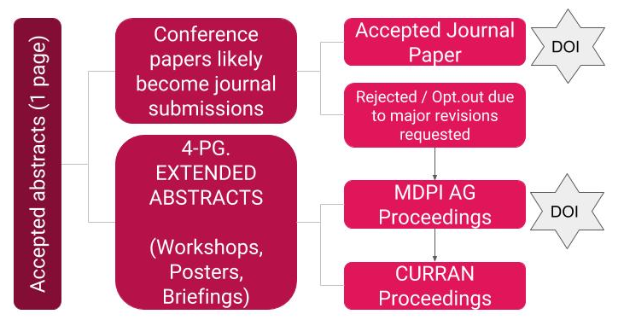

Section 4-A) Conference timeline for SP2018

Early-bird registration begins | 1st March 2018
Abstract proposals due | 1st April 2018
Decisions to authors | 15th April 2018
Early-bird registration ends | 31st April 2018
Late registration begins | 1st May 2018
Registration closes | 1st June 2018
SP2018 symposium | 27th-28th June 2018
SP2018 pilot site visits | 29th June 2018
Conference papers & extended abstracts (4 pages) due | 31st July 2018
Invitations to extend conference papers (8 pages) sent | 15th August 2018
Submission to journals (with correct formatting) due | 1st September 2018
Expected peer review completion and publication date | 31st December 2018

Section 4-B) Registration fees, procedure, and discounts offered

Conference fees & discounts offered (includes costs for the publications, networking events & pilot site visits) | - “Early-bird” registration fee (€300)  - “Late” registration fee (€350)  - “Co-author” registration*  - “Multiple”registration**  - “Student” registration***  - “Governmental” registration****
Discount criteria (non-cumulative) | - *Co-author”: Applies only to authors of papers, briefings, or posters (NOT to workshop chairs).  - 3 or more - 10% discount  - 5 or more - 25% discount  - 7 or more - 50% discount  - **Multiple”: To encourage the co-location of project general assemblies. Must be a proven documented consortium member.  - 3 or more - 10% discount  - 10 or more - 50% discount  - 15 or more - 75% discount  - 20 or more - 90% discount  - ***”Student”: Must provide a letter or proof of full-time enrollment via email.  - Bachelors - 50%  - Masters - 25%  - Doctoral/Postdoc - 10%  - ****”Governmental”: Applies to any member of a non-profit organization or a fully publicly-funded institution. The delegate(s) can benefit from a flat 25% discount, with proof of eligibility.
Forms of payment accepted (invoices upon request) | - Paypal  - Credit card (Visa, MC, Amex)  - Bank transfer
Cancellation policy | - For cancellation of registrations the fee payments made will be reimbursed after the event, as follows:  - 30 EUR (or 10%) for the administrative burden if registration was made before the "early-bird" deadline, or  - 60 EUR (or 30%) afterwards.  - No cancellation refunds are available after 1st June 2018 when registration officially closes.

Section 4-C) Journal submission procedure & scopes for SP2018 publications

All “full paper” abstracts that have been accepted into the SP2018 congress will first be extended to 4 pages and again extended for their submissions (up to 8 pages excluding appendices) by relevance for one of the below five OPEN-ACCESS special journal issues. Rejected papers during the peer-review or authors who opt-out if major revisions are requested by the reviewers will publish the precedent 4-page abstract in the MDPI AG Proceedings Journal. Any journal fees for accepted papers, as well as the cost of publication in the Proceedings Journal shall be fully covered by SP2018.

Buildings  (MDPI AG)  “Heroes of Zero” | - Nearly/net zero-energy buildings (interventions...);  - Net-zero waste and net-zero water use in buildings;  - Passive & autonomous buildings (strategies, tech);  - Positive energy (blocks of) buildings & communities;  - Self-consumption & off/zero-grid locations & cases;  - Workforce upskilling & legislation towards net-zero;  - Initiatives towards 100% renewable energy sources;  - Cost-benefit analyses & net-zero funding schemes;  - Impact of net-zero in building stock & climate, etc.
Daylighting (SolarLits)  "Agile Aesthetics" | - Add-ons, recyclable, & reusable building materials;  - Prefab assemblies & high-performance composites;  - Building-integrated renewable & storage technology;  - Indoor environmental quality analyses & solutions;  - Living & breathing (double) skins with airtightness;  - Moving buildings & kinetic architecture installations;  - Smart & energy-efficient lighting cases in buildings;  - Lighting assessment (illuminance, photometrics…);  - Innovations in refit (insulation, glazing, ventilation..);  - Translucency / electrochromism & curtain walls, etc.
Designs  (MDPI AG)  “Ethical Strategem” | - Component & high-performance material design;  - Circular economy innovations of energy-efficiency;  - Design-performance tradeoff in urban regeneration;  - Ecodistricts & societies in energy transition design;  - Facilities management & infrastructure planning;  - Geothermal energy & thermodynamics in design;  - Holistic & deep energy retrofitting strategy design;  - Process improvements & value interaction design;  - Technological products/services & market design;  - Optimization for local sharing & eMobility design;  - Biophillic design (city, land, buildings, systems); etc.
Energy, Sustainability and Society (Springer)  “Prosumer Paradigm” | - Buildings, facilities, and home energy management;  - Construction project & urban habitat management;  - Big data privacy & grid (cyber)security management;  - Decarbonization initiatives & nature-based solutions;  - Demand side response tools & ICT in peak shaving;  - Distributed renewables generation & load balancing  - Electricity grid reliability & congestion management  - Flexibility commoditization & energy governance  - Stakeholder requirements & user acceptance study  - Battery storage of renewable energies management  - Social housing amelioration & energy communities, etc.
Information Technologies and Control  (De Gruyter)  "Conclusion Fusion" | - Automation & digitalization for internet of everything  - Blockchain (for buildings, construction, energy, etc.)  - Energy simulation & 3D visualization of data models  - Monitoring of performance metrics & methodologies  - Self-healing, fault-detection, & context awareness  - Semantic ontology engineering & interoperability  - Sensors & actuators towards embedded intelligence, etc.

All queries should be sent to the SP2018 conference chair: Zia.Lennard@R2Msolution.com

