Sustainable Places 2023: Call for Proposals

Submissions to SP2023: our call for proposals will be open until **May 14th**.

In case you have any doubt or concern about SP23, please contact us at [sustainableplaces@r2msolution.com.](mailto:sustainableplaces@r2msolution.com) We will study your requests on a case by case basis, taking into account agenda & on-site room availability constraints.

For workshop organisers, you are invited to keep us updated with changes related to the

workshops you are organising (e.g. new projects / participants joining) so that we can update your workshop promotional page accordingly.

Thank you!

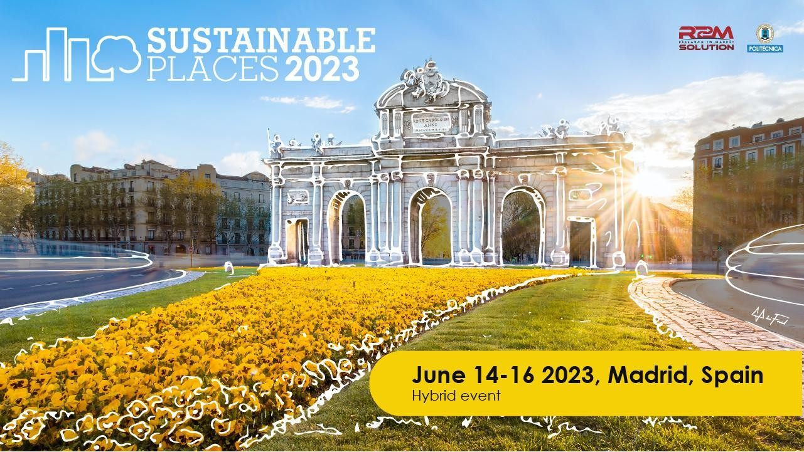

# CONTACT

* + Name :
  + Organisation :
  + Email:

# HOW DO YOU PLAN TO ATTEND

|  |  |
| --- | --- |
|  | In presence (Madrid, Spain) |
|  | Online |

1. **THEME**

Please check the topics associated with your submission:

|  |  |
| --- | --- |
|  | Sustainable Construction & Renovation |
|  | Energy Communities, Smart Cities and Urban Transition |
|  | Digitalization, Smartness & Artificial Intelligence |
|  | Facilitating the energy transition: Policy, Finance, Training |
|  | Renewable Energy Technologies |
|  | Decarbonization & Circularity, Climate Change mitigation and adaptation |
|  | Sustainable Urban Renewal & Cultural Transformation |
|  | Resilience and Energy Security |
| Other theme(s): | |

# TYPE

|  |  |
| --- | --- |
|  | Paper (20’ presentation; 1 required registration; peer-reviewed article*) |
|  | Workshop (4 required registrations; optional peer-reviewed article*) |
|  | Presentation (20’ presentation; 1 required registration; no article submission) |

* *All articles will be published through Open Research Europe in a specific collection dedicated to Sustainable Places 2023. Submissions are due by 31st of July, 2023. Articles can be published in various formats such as Research Articles, Brief Reports, Data Notes, Method Articles, Software Tool Articles, Reviews, Case Studies or Open Letters. More information can be found on the Article Guidelines. Please also be sure to read the open access publishing model and peer-review process. Your article must meet the following eligibility criteria:*
  + *At least one author must be involved in a running or finished Horizon 2020 or Horizon Europe project from the European Commission and the article must be a result of that project.*
  + *The article must be original work (see section on originality).*

# PROPOSED SUBMISSION

TITLE (kindly avoid all jargon and restrict abbreviations to project acronyms)

ABSTRACT. Please submit an abstract of your contribution. The topic, purpose of submission, approach, and innovative results (if applicable) must be clear from the abstract.

*3000 character(s) maximum*

*0 out of 3000 characters used.*

Question

WORKSHOP | Please provide details on your workshop methodology & expected collaborative outcomes. Workshops may be clustered into thematic sessions depending upon the number of requested sessions. Do ensure you build your own audience to help ensure you have a successful workshop / the desired outcome. If you are requesting a private workshop – please indicate this.

*1500 character(s) maximum*

*0 out of 1500 characters used.*

1. **DURATION AND MODALITY** (Only applicable for workshops) Choose your preferable workshop duration:

|  |  |
| --- | --- |
|  | 90 minutes |
|  | 180 minutes |
| Other duration: | |

Choose your preferable workshop modality:

*Please, take notice that this year the workshops will be available as in-person or online mode, but hybrid format workshops (where presenters are both online and in Madrid) are not envisioned.*

|  |  |
| --- | --- |
|  | In person (Madrid, Spain) |
|  | Online |

1. **CONFERENCE ATTENDEES** Please list all expected presenters. (Co-authors to be listed on papers who will not attend the conference should not be listed).

|  |  |  |  |
| --- | --- | --- | --- |
|  | Name | Organization | Email |
|  |  |  |  |
|  |  |  |  |
|  |  |  |  |
|  |  |  |  |
|  |  |  |  |
|  |  |  |  |
|  |  |  |  |

|  |  |  |  |
| --- | --- | --- | --- |
|  |  |  |  |
|  |  |  |  |
|  |  |  |  |
|  |  |  |  |
|  |  |  |  |
|  |  |  |  |
|  |  |  |  |

# Please, let us know if you have any inconvenience in presenting during any of the days of the conference

1. **UPLOAD YOUR PROJECT(S) LOGO(S)**
2. **AGREEMENT OF THE SUBMITTER** Upon acceptance of a submitted abstract, the submitter agrees:
   * To register for the conference. At least one of the authors must register (and pay the correct registration rate) to the conference.
   * For workshops contributions, a minimum of 4 paid registrations are required.
   * Registration and travel costs are the attendees’ responsibility.

**\***

* I accept your Terms