Sustainable Places 2024 | Call for Proposals

Fields marked with * are mandatory.

**Application Form for Late Submissions (after 31 May 2024)**

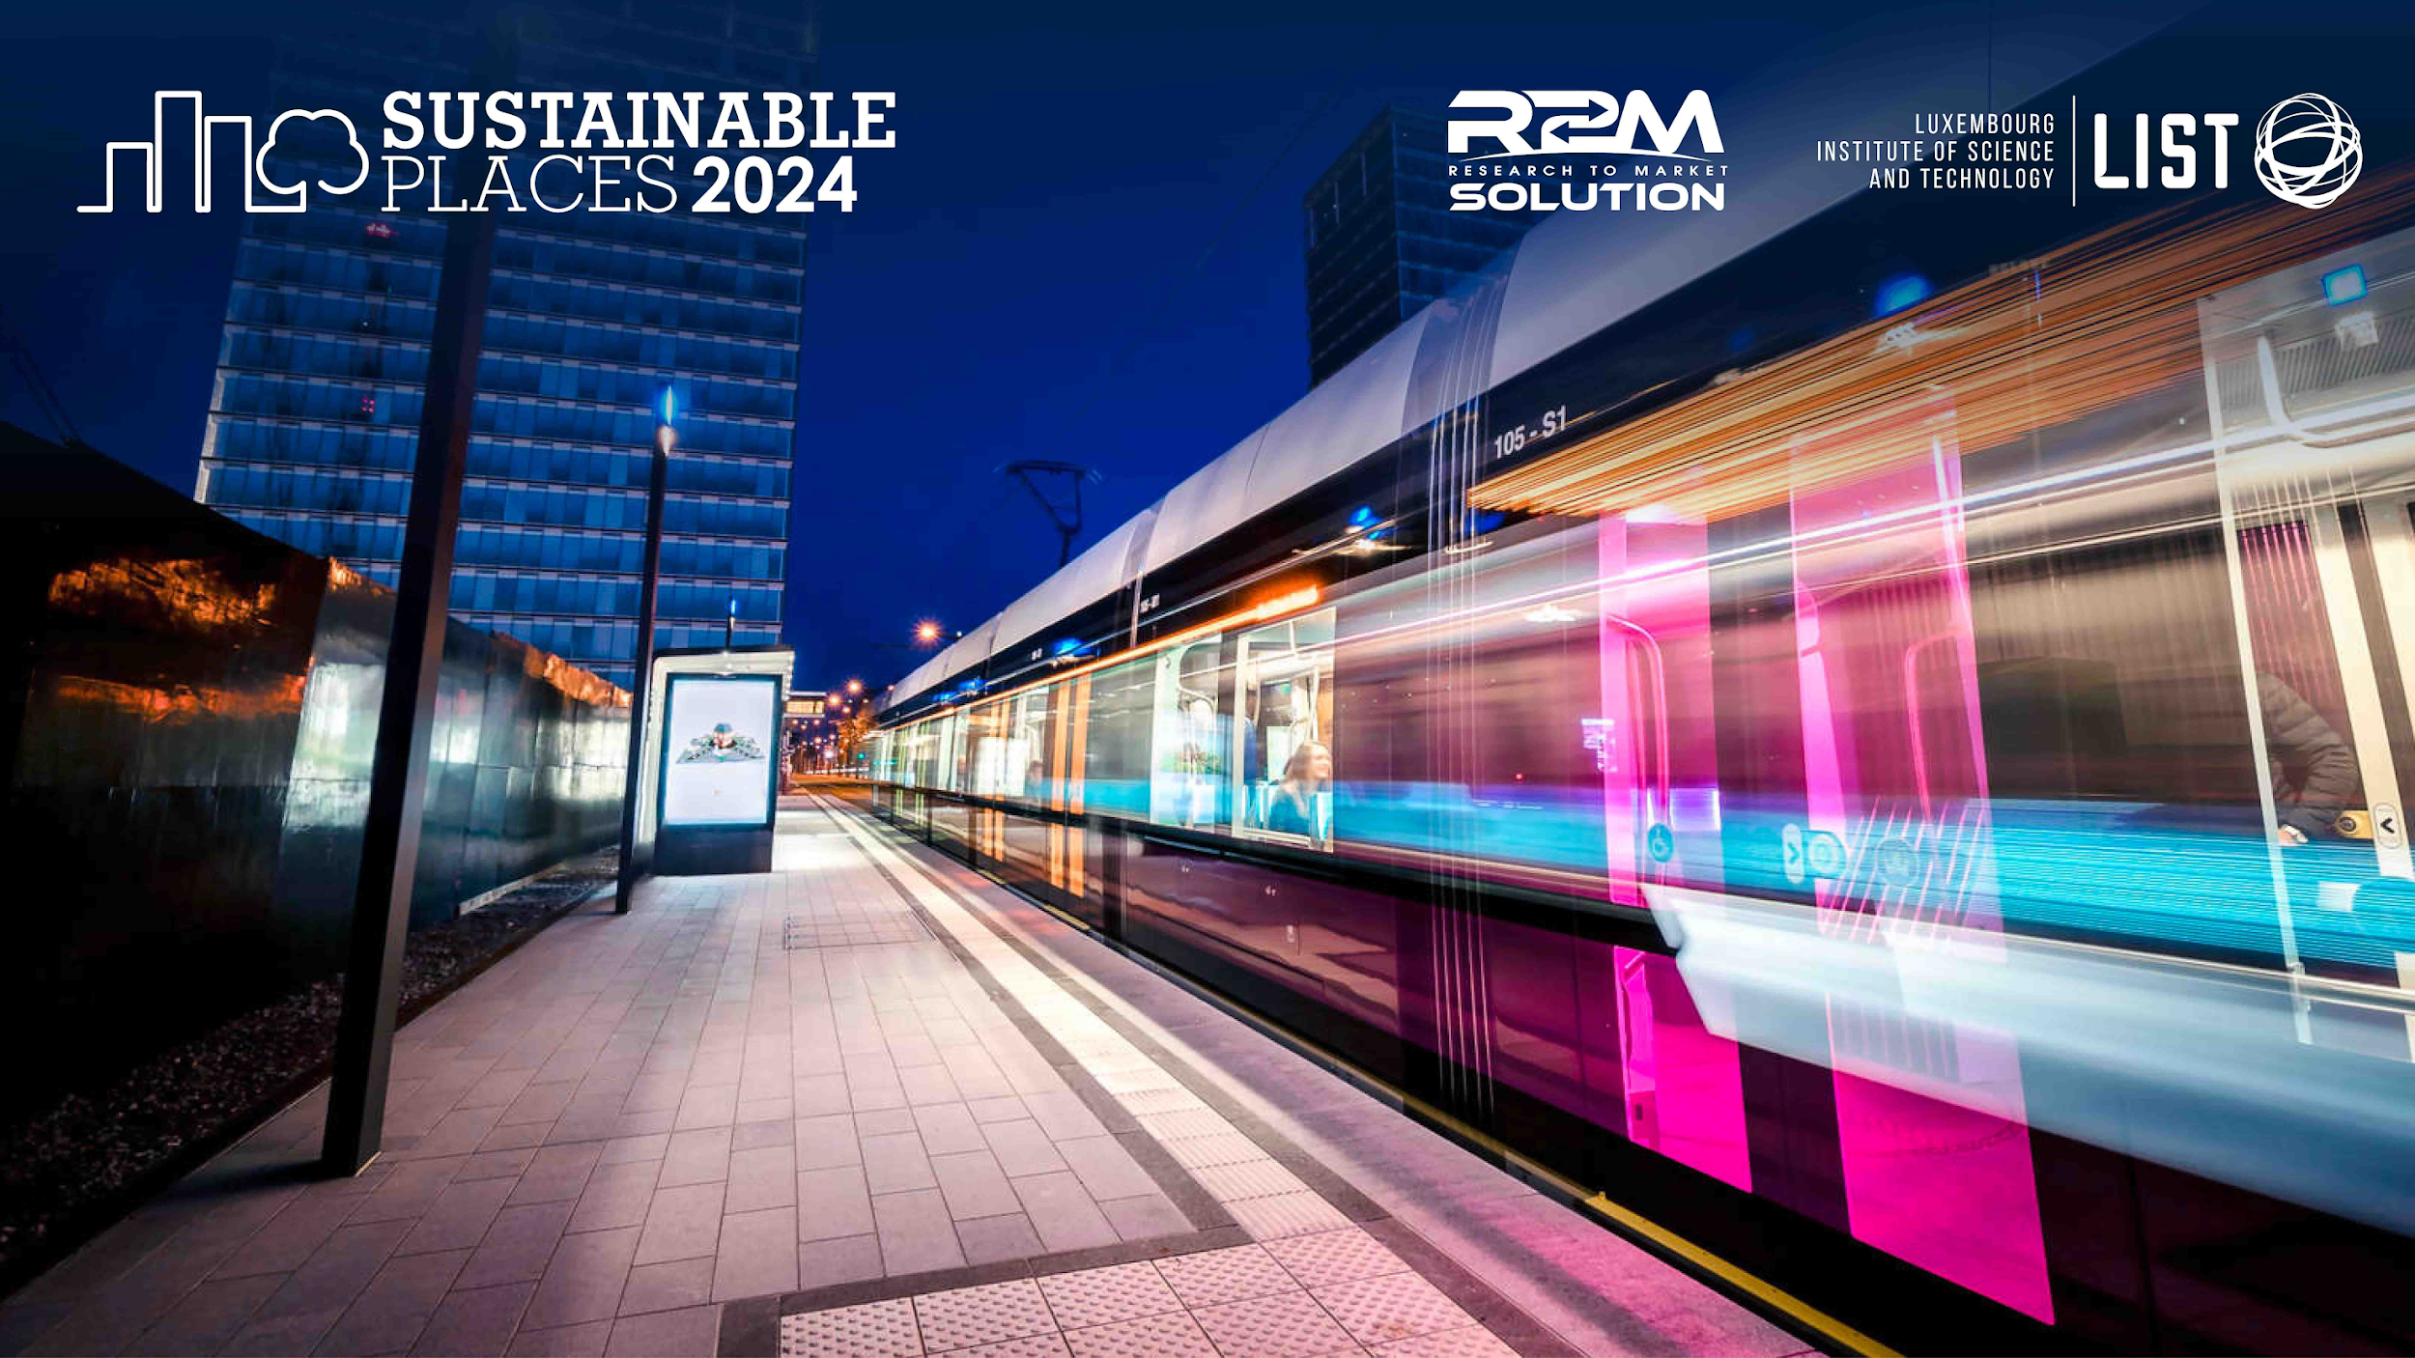

**1. CONTACT**

* Name

|  |
| --- |
|  |

* Organisation

|  |
| --- |
|  |

* Email

|  |
| --- |
|  |

* **2. THEME(S)**

Please highlight the topics associated with your submission :

Energy communities, smart cities and urban transition

Sustainable construction and renovation

Climate change mitigation and adaptation

Facilitating the energy transition: policy, finance, training

Sustainable Urban Renewal & Cultural Transformation

Renewable Energy Technologies

Decarbonization & Circularity

Resilience and Energy Security

Digital twins, smartness and artificial intelligence for sustainability Other [please write your theme(s) below, all are welcome]:

Other theme(s)

|  |
| --- |
|  |

* **3. MODALITY AND TYPE**

*Please highlight at most 1 choice*

**In-person**

**Online**

**Not sure yet**

*Please highlight at most 2 choice(s)*

**Paper** (20’ presentation; 1 required registration; peer-reviewed [article](https://open-research-europe.ec.europa.eu/for-authors/article-guidelines/science-technology-and-medicine/)*)

**Workshop** (5 required registrations; optional peer-reviewed [article](https://open-research-europe.ec.europa.eu/for-authors/article-guidelines/science-technology-and-medicine/)*)

**Presentation** (20’ presentation; 1 required registration; no article submission)

**Rollup Poster**\*\* (NO presentation; 1 required registration; optional peer-reviewed [article](https://open-research-europe.ec.europa.eu/for-authors/article-guidelines/science-technology-and-medicine/)*)

* All articles will be published through [Open Research Europe](https://open-research-europe.ec.europa.eu/) in a [specific collection dedicated to](https://open-research-europe.ec.europa.eu/collections/sp2024/about)

[Sustainable Places 2024.](https://open-research-europe.ec.europa.eu/collections/sp2024/about) Submissions are due by 31st October 2024. Articles can be published in various formats such as Research Articles, Brief Reports, Data Notes, Method Articles, Software Tool Articles, Reviews, Case Studies or Open Letters. More information can be found on the [Article Guidelines page](https://open-research-europe.ec.europa.eu/for-authors/article-guidelines/science-technology-and-medicine). Please also be sure to read the open access [publishing model](https://open-research-europe.ec.europa.eu/about) and [peer-review process](https://open-research-europe.ec.europa.eu/for-authors/tips-for-finding-referees). Your article must meet the following eligibility criteria:

* At least one author must be involved in a running or finished Horizon 2020 or Horizon Europe project from the European Commission and the article must be a result of that project.
* The article must be original work (see section on [originality](https://open-research-europe.ec.europa.eu/for-authors/publish-your-research/)).

** Displayed in the exhibition area(s) if a rollup display stand is provided by the poster author.

**4. PROPOSED SUBMISSION**

* **TITLE** (kindly avoid all jargon and restrict abbreviations to project acronyms)

|  |
| --- |
|  |

* **ABSTRACT**

Please submit an abstract of your contribution. The topic, purpose of submission, approach, and innovative results (if applicable) must be clear from the abstract.

*3000 character(s) maximum*

|  |
| --- |
|  |

1. **CONFERENCE ATTENDEES** Please list all expected presenters and whether they plan to attend physically, virtually, or are not sure yet (Co-authors to be listed on papers who will not attend the conference should not be listed).

|  |  |  |
| --- | --- | --- |
| Name | Organisation (and project) | Email |
|  |  |  |
|  |  |  |
|  |  |  |
|  |  |  |
|  |  |  |
|  |  |  |

Please send related project logo(s) to be included in SP2024 marketing collateral

1. **AGREEMENT OF THE SUBMITTER** Upon acceptance of a submitted abstract, the submitter agrees:

* At least one of the authors must register (and pay the correct registration rate).
* A minimum of 5 paid registrations are required for workshops.
* Registration and travel costs are the attendees’ responsibility.